**Selenium Features:**

**1. Multi-Browser Support**

Selenium is capable of interacting with web apps and the web elements in a browser just like a real user would. Selenium does that by using a browser native support that makes direct calls without the use of any intermediary device or software. Almost all browsers are supported by Selenium – Chrome, Safari, IE, Opera, Edge, and Firefox.

**2. Multi-Language Compatibility**

Selenium supports almost all programming languages like PHP, Java, Python, JavaScript, Perl, Ruby, etc. You can write automation test scripts using any programming language you feel comfortable with. You can also use switch statements, conditional statements, or decision-making statements to enhance your automation test script. This step will make your test script capable of handling all kinds of situations.

**3. Easy Identification and Use of Web Elements**

Selenium makes it easy to identify web elements on the web apps with the help of several [Selenium locators](https://intellipaat.com/blog/locators-in-selenium/). This makes the implementation of the elements much easier in the test automation suite. There are various [Selenium IDE](https://intellipaat.com/blog/tutorial/selenium-tutorial/selenium-ide/) you can add to your web via extensions.

**4. Performance and Speed**

Selenium has a particular component for the automation of web app testing called WebDriver. This tool is able to execute test cases quicker than the other tools. It is capable of communicating directly with the browser so there is no requirement for intermediaries like the server.

**5. Dynamic Web Elements**

Contains(): You can use a partial text to find an element.

Absolute XPath(): This XPath can easily handle dynamic web elements. It comes with a complete set of paths for web UI automation, right from the root node.

StartsWith(): Selenium is capable of handling dynamic web elements with ease. It utilizes some of the following methods to do that:

This function helps find an attached attribute to a dynamic web element by matching or finding the starting text.

**6. Open Source**

Selenium is open-source software. It can be easily downloaded from the official Selenium website.

**7. Portability (Ability to work with different Operating Systems)**

Selenium is portable software. It can work with different Operating Systems like Linux, Mac, UNIX, and Windows.

**8. Reusability and Extras**

All the scripts written with the help of Selenium are capable of supporting browser compatibility testing. The extra plugins help widen the scope of application testing and they can be customized.

**9. Commands**

All the commands used in Selenium are pretty simple to implement.

**10. Take less time to execute a test**

Selenium reduces the test execution time. This helps make the execution more reliable and faster.

**11. Server installation is not required**

You don’t need to install a server for Selenium. Selenium can interact directly with the browser.

**12. Selenium WebDrivers – Classes and Methods**

[Selenium WebDriver](https://intellipaat.com/blog/what-is-selenium-webdriver/) is an important tool offered by Selenium. It provides a lot of solutions for some potential problems in automation testing. It also helps testers deal with complex web elements like radio buttons, dropdowns, alerts, etc. by using dynamic locators.

**13. Easy Testing**

Selenium allows users to automate test scripts across different devices like Android, iPhone, etc.

**14. Combination of Tool and DSL**

[Selenium](https://intellipaat.com/blog/tutorial/selenium-tutorial/introduction/) is an absolute combination of tools and DSL (Domain Specific Language) in order to carry out various types of tests. It allows you to record the tests carried out through the browser. It supports multiple web browsers like Internet Explorer, Safari, Firefox, Chrome, etc.

**15. Uses a rich language for tests**

Selenium uses DSL in order to test web applications. This language includes 200 commands and is an easy programming language to learn.

**16. Lesser resources required**

Selenium requires lesser resources when compared to its competitors like UFT, RFT, etc.

Drawbacks of Selenium

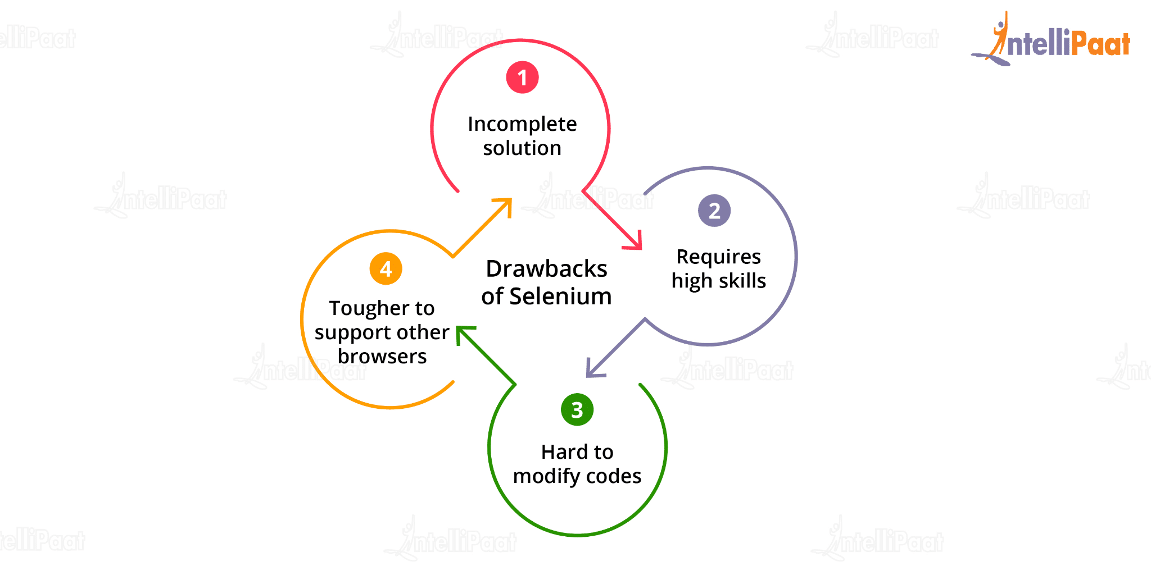

Incomplete solution – Selenium requires third-party frameworks in order to completely automate the testing of web applications.

Requires high skills – Though it supports multiple programming languages, it requires a high-level proficiency to deal with it effectively.

Hard to modify codes – The scripts written in Selenese are not user-friendly which makes it hard to modify the codes.